FACULTY EVALUATION
Programme Name: SBVP ALUMNI MASTERCLASS Online s Module 2 Kenya: (4th May 2026 - 8th May 2026)
Session: Review (identify gaps/challenges) your business Canvas from module || Decide key issues for long-term sustainability || Identify areas where support is needed
Faculty Name: Dr. William Murithi
No. of Respondents: 15
No. of Participants: 15
Evaluation Parameter | (%) Individual Score | (%) Programme Average
Punctuality (Commencement and Completion of Sessions) | 92 | 95
How well do you understand the core concepts presented? | 89 | 90
Rate your confidence in applying the new skills learnt | 81 | 85
Degree of Faculty preparedness for the sessions | 93 | 96
Content and methodology of the program | 91 | 93
Quality of class and group discussions | 92 | 90
The information presented in the course is relevant to my work (ministry) | 92 | 94
Average scores | 90 | 92

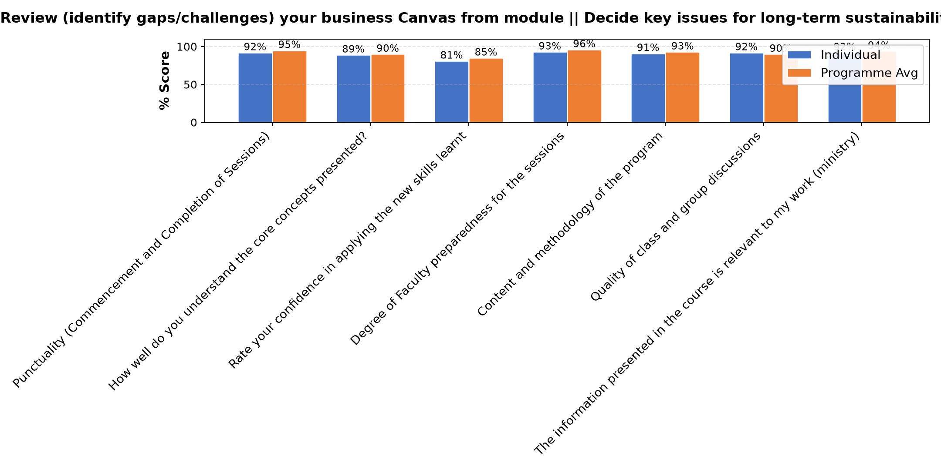

Comments & Feedback
- • Financial constraints
- • Finance issue
- • Making decisions on when the work should start because of financial constraints
- • Nothing
- • Lack of expert support
- • Financial constraints for implementation
- • Financial resources
- • Delayed decisions and fear of taking financial risks. Talent deployment mismatch and poor strategy on the utilisation of resources
SUBMITTED THROUGH:
SBS Evaluation Automation System

